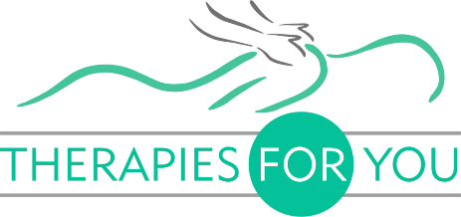
POLICY AND PROCEDURE RELATED TO COVID-19 SAFETY

While COVID-19 is still present in our community, Therapiesforyou will operate with these changes to standard policies and procedures to protect staff and client safety.

Appointments only: Please call ahead to make an appointment.

Late Cancelations: I will waive the late cancelation policy for anyone who develops a fever or symptoms of illness. Please let me know if you feel unwell and I will cancel your appointment without charging you a fee.

Pre-Session Screening: Please expect a phone call or email health screening 24 hours before your massage appointment. I will ask:

- Have you experienced any cold or flu-like symptoms in the last 14 days or has a health professional asked you to self-isolate in the last 14 days?

- Have you been in close contact with someone experiencing cold or flu-like symptoms or have you cared for someone testing positive for COVID-19 in the last 14 days?

- Have you been tested for COVID-19 in the last 14 days and if yes, what was the result?

If for any reason, I cannot get in touch with you, these questions will be asked on your arrival, before you enter the treatment room.

Arrival Procedure: When you arrive at Therapiesforyou I will follow a strict protocol to ensure your safety and mine:

- Please wait patiently outside and do not attempt to enter ie touch door handles. I will let you know when I am ready for you to come in.

- I will greet you at the door and take your temperature with a no-touch thermal temperature reader to make sure you don't have a fever. If your temperature is over 38 degs you will be required to reschedule your appointment.

- I will ask if you have any symptoms of illness including a cough or digestive issues. If you have a fever or symptoms of illness, I will reschedule your appointment to a later date.

- I will ask you to clean your hands with an alcohol-based hand sanitizer. Should you not have a proper facemask, your session will be rescheduled.

While COVID-19 is present in the community I will request that we limit talking to only communication necessary for ensuring a comfortable and safe massage. I will also ask you to leave promptly after your session.

If you develop symptoms of illness or test positive for COVID-19 within two weeks of your massage session, please let me know immediately.

I will follow up to check in on your health 1 week and 2 weeks after your session.

